https://www.facebook.com/Ramongaliai/posts/1494523364288404

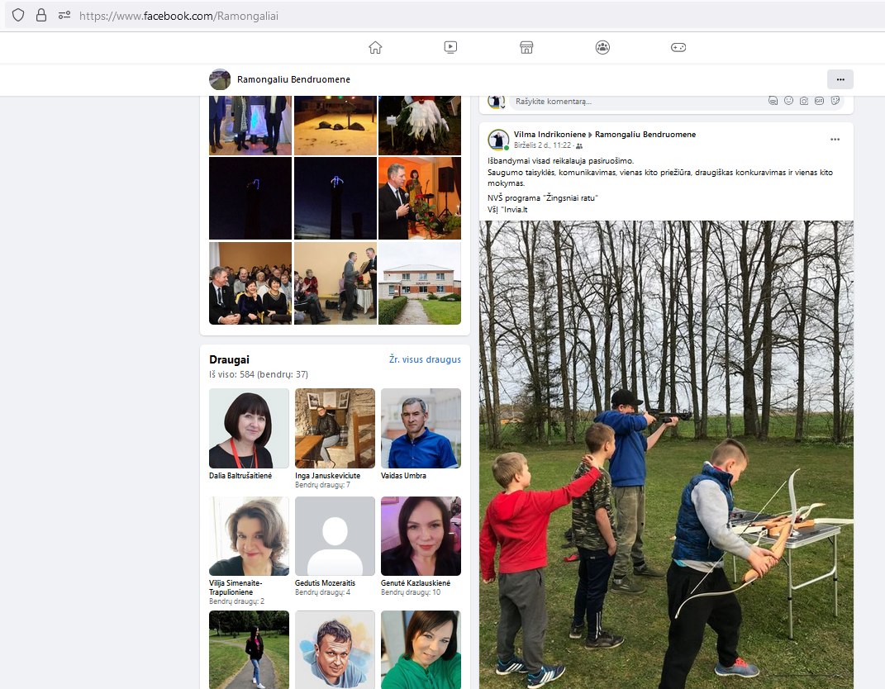

https://www.facebook.com/Ramongaliai/posts/1453261258414615
