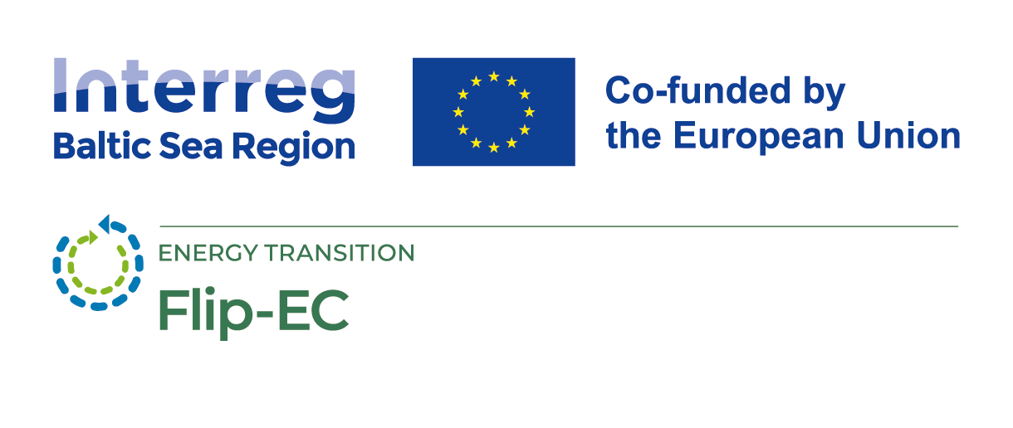
General information

Project name: Flipped Energy Concept to Flip Climate Change (Flip-EC)

Project period: March 2025 – February 2028

Project cost: EUR 3.04 million, including ERDF contribution of EUR 2.44 million.
Biržai district municipality share is EUR 240 849, including a grant of EUR 192 679.

Website: https://interreg-baltic.eu/project/flip-ec/

Funding programme: Interreg Baltic Sea Region 2021-2027

Project description

The aim of the project is to develop a set of methods to improve the energy efficiency of public buildings.

Project background:
- Poor energy performance of many public buildings
- Energy efficiency measures are one-off and of limited impact
- Unclear responsibilities
- Lack of cooperation

Project approach:
- Motivate building users to contribute to energy efficiency
- Engage and provide practical knowledge
- Achieve sustainable behavioural change

Project partners

The Flip-EC consortium includes 11 partners from 6 countries:
- Germany: Hanseatic City of Lübeck (Lead Partner) and Eduversum
- Latvia: Smiltenes Municipality, Social Innovation Centre (SIC) and Liepāja State Technical School (LSTS)
- Lithuania: Biržai District Municipality and Lithuanian Innovation Centre (LIC)
- Poland: Regional Development Agency in Bielsko-Biała (ARRSA) and Foundation Institute for Sustainable Development (ISD)
- Estonia: Development Centre of Võru County
- Denmark: Brøndby Municipality

Project activities

Three work packages are planned:

WP 1 Preparing solutions
- Preparing cooperation and user participation + gaining transparency
- Preparing users involvement, empowerment and task sharing
- Preparing knowledge transfer to provide an energy efficient operation
- Preparing monitoring and data transparency

WP 2 Piloting and evaluating solutions
- Structural implementation of cooperation, participation & transparency
- User empowerment & task-sharing
- Testing knowledge transfer methods
- Real-world laboratory: testing monitoring tools to evaluate pilot activities

WP 3 Transferring solutions
- Flip-Hub
- Train the trainer material, events and dissemination conference

